CaRunners
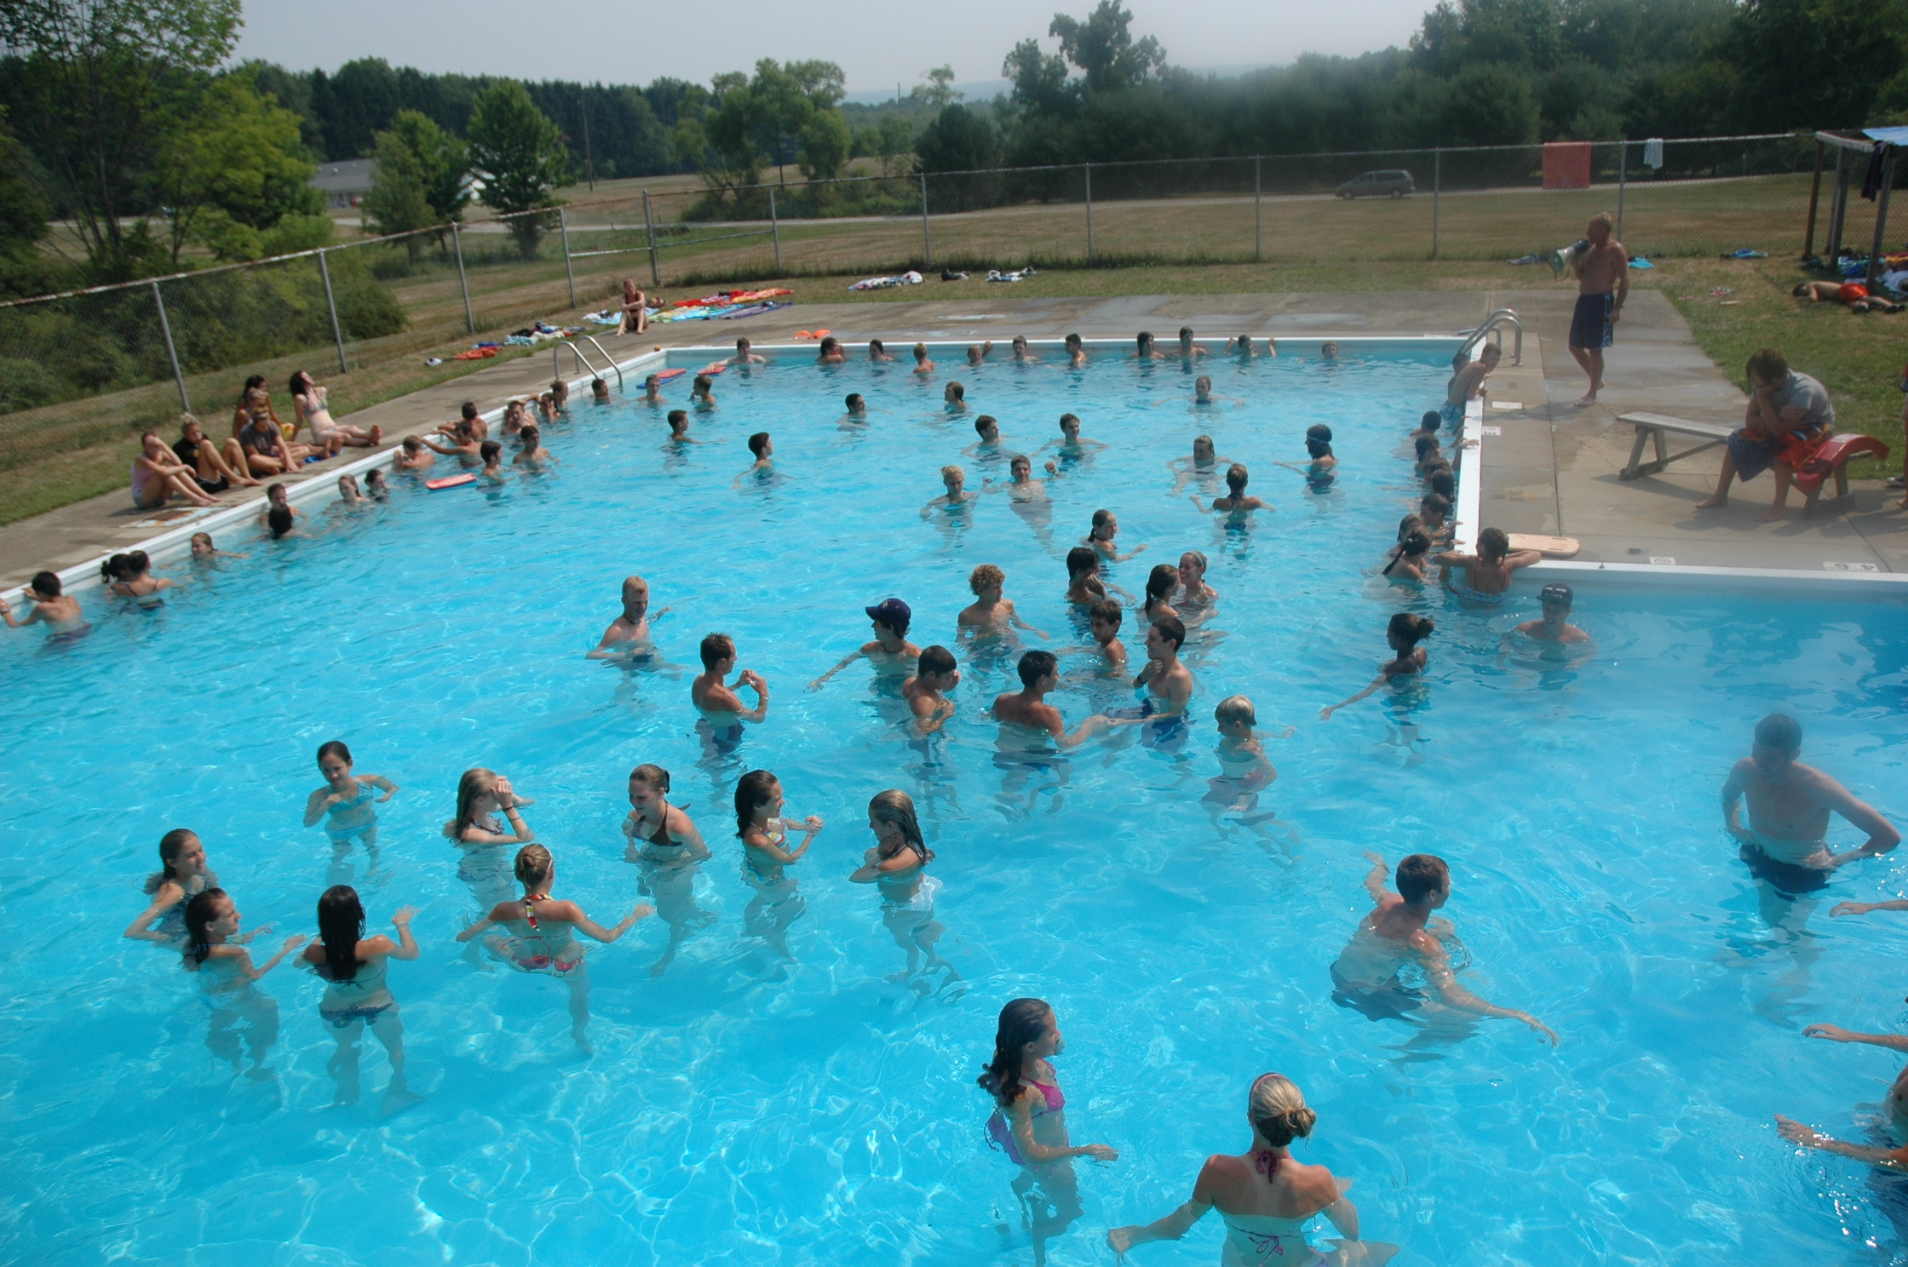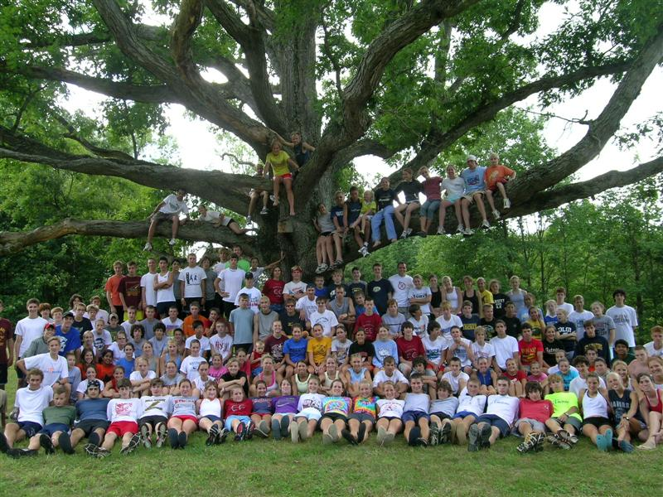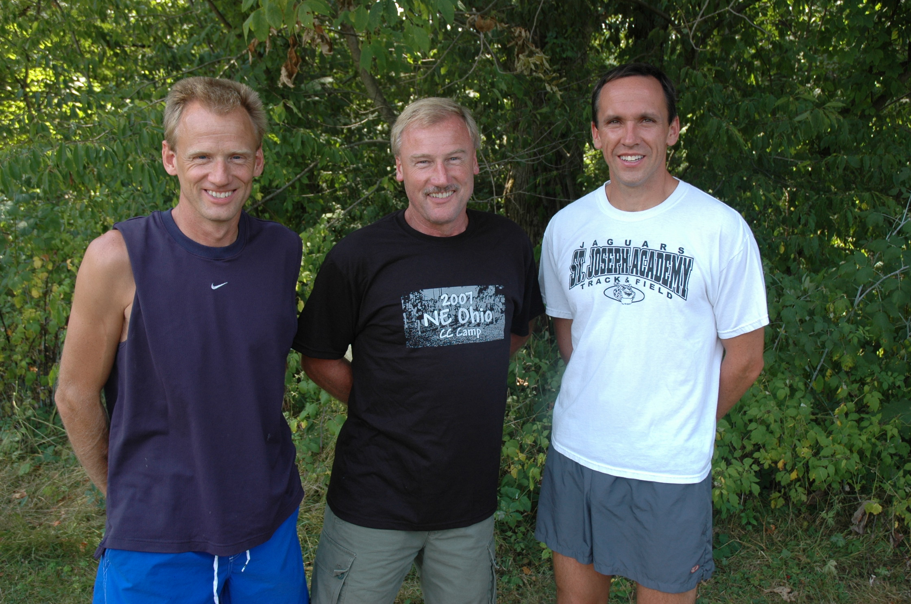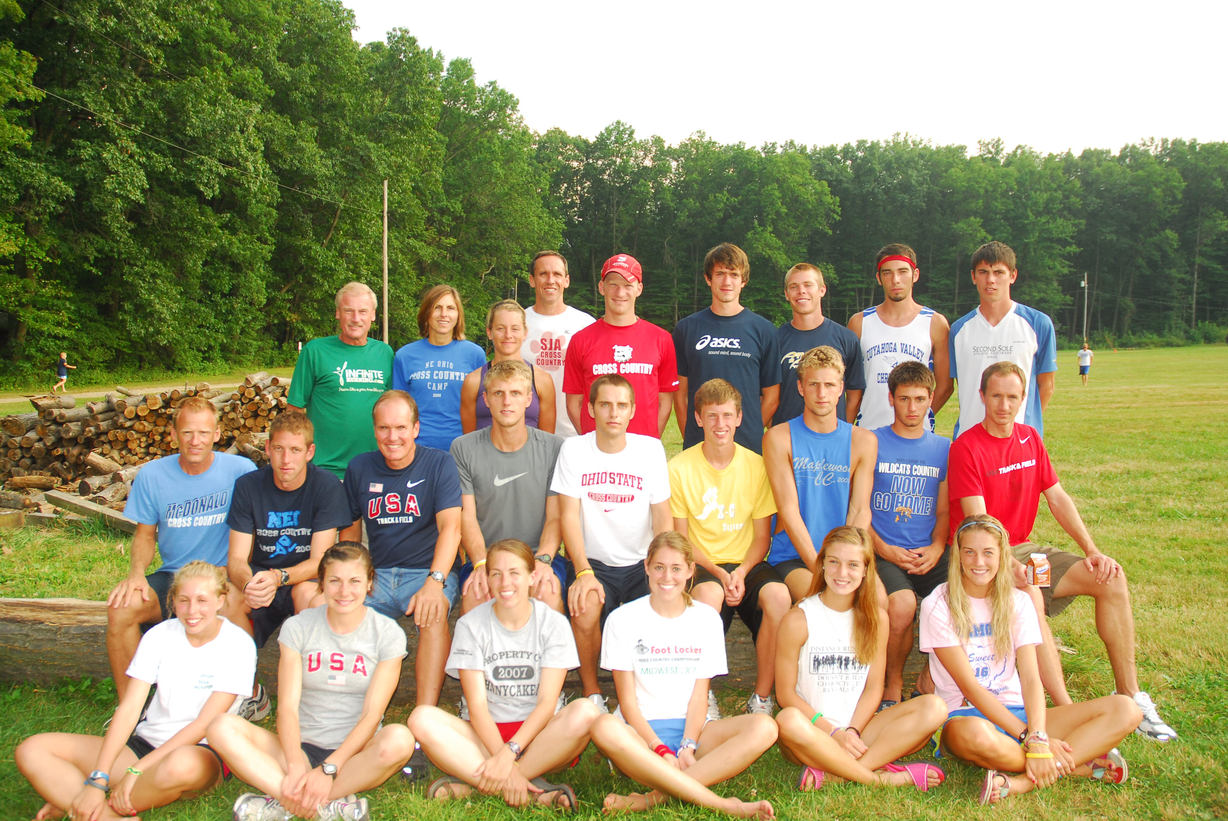
7:00 - 7:15 AM | Wake up / Stretch
7:15 - 8:30 AM | Morning Run / Shower
8:30 - 9:30 AM | Breakfast
10:00-11:30AM | Morning Recreation
11:30 -12:30PM | Morning Clinic / Swim
12:30 PM | Lunch
1:30 - 3:00 PM | Afternoon Recreation or Rest
3:00 - 3:30 PM | Afternoon Clinic
3:30 - 5:30 PM | Afternoon Run / Shower / Swim
6:00 PM | Dinner
7:00 - 8:00 PM | Evening Recreation
8:00 - 9:30 PM | Evening Meeting
10:30-11:00 PM | In Cabin
11:00 PM | Lights Out - Sleep!

- Clinics at camp will be over topics including training, racing, diet, psychology of running, stretching, body composition, form, injuries, training logs and shoes.
- Nightly speakers discussing these and other topics will include college coaches, exercise physiologist, athletic trainers, shoe experts and top national runners.
- Camp participants will also receive:
- Souvenir camp T-Shirt
- Packet of running related gifts
- Booklet of discussion topic handouts
- Three meals per day
The NE Ohio CC Camp will be held at Badger Meadows Camp in Orangeville, OH, 10 miles east of Cortland. The 240 acre camp offers fine facilities including an Olympic size swimming pool, volleyball and basketball. The camp is in a rural setting, offering trails and rural roads for training. Runners will sleep on bunks in cabins that hold 12-15 campers. The camp is owned by the Presbyterian Church. Campers are expected to respect the facility and treat it accordingly.
More camp info can be found at www.gopherarun.com
THE CAMP
The directors and staff of the NE Ohio CC Camp share the philosophy that lasting success in distance running must come from within the athlete. Regardless of the enthusiasm that coaches and parents share for the runner, the level of success will ultimately depend upon the runner’s dedication and determination. The camp is thereby committed to instilling an attitude of enjoyment in each runner. For only when the runner learns a love of the sport, will they develop a work ethic allowing them to establish challenging goals and put forth the necessary training to accomplish these goals.
The camp is geared toward the junior high and high school runner that has a positive attitude towards self improvement through training designed to be strenuous yet rewarding.
The training runs at the camp will be broken into low, intermediate and upper mileages. Each runner should be in adequate condition to run a minimum of 6 miles each day, with the intermediate group covering an average of 8 miles each day and the upper group 10-12 miles.
CAMP DIRECTORS

2012 will mark the 33rd year for the NE Ohio CC Camp. Directors will be Ted Rupe, Chris Rupe and Fred Kieser. This trio along with the accompanying staff represents some of the finest runners and coaches in the Midwest United States.
Ted Rupe - In his over 40 years of competition and coaching, Ted has accumulated some fine credentials. He was the 1972 State CC Champion in Div. A, leading his team to the state title. He was world ranked in the 10 K in 1977, won the Cleveland Revco Marathon in 1986 and the 1986 Moscow Peace Race. As a coach, his teams have qualified for 20 straight state CC championships, 14 of these teams finished in the top 4 at the Ohio State Championships, including a 1997, 2002, 2003 and 2005 State Championship and runners up in 1990, 1998 and 2001. He also coached the 2000 track team that tied for a state championship. He was selected as Ohio’s High School CC Coach of the Year for 1997-1998. Ted was inducted into the Ohio Track and Cross Country Hall of Fame in 2003 for his accomplishments.
Chris Rupe - boasts a 14:37 5k, and 24:10 for 5 miles and 2:21 marathon. He has finished as top Ohioan twice at Cleveland Marathon and twice at Columbus Marathon. Recently at McDonald HS he has coached 5 state championship 4x800 relay teams and state champions Becky Testa, Stuart Henderson and state record holder Ed Stonestreet. His 1999 Track and Cross Country teams were both state champions. His 2001, 2004 and 2011 CC Teams also won the state championship, while his 2000, 2002, 2003, 2007 and 2010 squads were runners-up.
Fred Kieser - Finished as the 2nd place individual in the1988 Ohio State CC Meet and ran on a State Championship 3200m Relay Team the following spring. While he still competes on the track and in cross country meets, Fred's greatest success has been at the marathon distance. In1993 he was the top Ohioan and third American in his debut marathon atColumbus. Since that time he has won 3 marathons (Detroit 1999, Blackpool England 2000, and Cleveland 2005) and has qualified for 2 Marathon Olympic Trials finishing 14th in 2000 and 13th in 2004 where he ran a PR of 2:17:20. He has college coachingexperience and has taken the high school team that he coaches, St. JosephAcademy, to the state meet 8 times since 2000. In 2002 his team captured 4th place in the DivisionI girls state championships. He still currently competes at the national level in Masters competitions.
CAMP SCHEDULE
A typical day at camp includes:
CAMP PHILOSOPHY
REGISTRATION
INFORMATION

Registration in the 2012 NE Ohio CC Camp must be completed online. Camp information will be communicated through the website and email.
Registration requires two steps:
- Log onto www.gopherarun.com and complete the online application form
- Mail a $50 non-refundable deposit to the address below.
The total cost of the camp is $260 per runner, the balance being due upon check-in at camp or mailed in prior to camp registration. There are also some forms that will need to be completed prior to camp and mailed in. Those forms will be emailed to you. All runners attending camp will be required to send a copy of their school physical form. We encourage runners to mail in the forms along with the balance of their payment prior to arrival at camp so that camp check in can be easier for you.
Two sessions of camp will be held this year; July 22-27 and July 29-Aug 3. Registrants will be accepted on a first come, first serve basis until the camp capacity of 230 registrants is reached for each session. Last year this limit was reached in the middle of May. The NE Ohio CC Camp reserves the right to reject registrations to the camp to comply with both safety and disciplinary standards.
If internet access is unavailable for you to register online - Detach and mail the following form and deposit to:
NE Ohio CC Camp
2533 Davis Peck Road
Cortland, OH 44410
Make checks payable to: Gopher Running
- - - - - - - - - - - - - - - - - - - - - - - - - - - - - - - - - - - - - - - -

Above is the staff from the 2011 NE Ohio CC Camp. The staff for the 2012 NE Ohio CC Camp will include many of the same staff with some additions:
- Cory Leslie – Graduating senior from Sandusky Perkins HS – 2007 Div II CC State Champion, 2007 State Track 1600m champion. During his 2011 indoor track season, Cory ran a 3:57.97 mile to rank him 2nd in the world.
- Bridget Franek - Sophomore at Penn State where she qualified for the NCAA CC Nationals - Bridgette holds the Ohio State Record in the 1600m in 4:45.68 which she ran in the 2005 State Track Meet. She also won the 2005 State Cross Country Title in 17:34 and qualified for the 2005 Foot Locker Nationals.
- Adam Bray – competed for University of Akron. Has coached at University of Maryland and is currently coaching at the University of Illinois.
- Emil Heineking- ’06 State CC Champion and 3200m Champion, ’06 Footlocker Finalist. Currently a freshman at University of Virginia where he was All-American last fall in cross country.
- Rick Williamson - Has run 3:51 for 1500 and 14:35 for 5K. Formerly men’s distance coach at Akron University and at Aurora High School. Currently coaching at Northwood University in Michigan.
- Matt Folk – Graduate of Youngstown State University where he now coaches. Matt has been named Ohio Runner of Year numerous times – competed in 2004 and 2008 Olympic Trials in the marathon.
- Brad Hunt – Distance coach at Wake Forest. Hunt placed fourth in the 800 meters and sixth in the mile at the 1997 Mid-American Conference Indoor Championships. He also was fourth in the 1,500 meters and sixth in the 800 meters at the 1997 MAC Outdoor Championships. Hunt also recorded the fourth-fastest indoor 800-meter time (1:52.81) in Kent State history during the 1996-97 campaign.
- Brian Gallagher – ’05 graduate of St. Ignatius HS now competes at Miami University. Qualified for the 2005 Ohio MidEast Championship Team.
- Craig Rupe – Completing senior year at University of Akron where he lettered in cross country and track and was CC Co-Captain. Was 1st Team All-Ohio as a senior in CC at Maplewood and was a member of two state championship CC teams and one track team.
- Cassandra Schenck – ’07 State Champion in both the DII 1600m and 3200m. 2006 State CC Meet runner-up. Led Crestwood HS to ’06 State Track Team Championship along with teammate Bridget Franek. Now a freshman competing at University of Akron.
- Tara Gruskiewicz – Coach at Avon HS. Ran 2:53 marathon last fall in Columbus.
- Chad Balyo – Sophomore at OSU. Chad was the Ohio State Div I Champion in both CC and the 3200m in track. Ran a spectacular 8:52 2-mile at Nike Outdoor Nationals, which converts to sub 9:50 for a 3200m. Also won 2006 MidWest Meet of Champions 3200m.

Updates on 2012 camp staff will be listed on www.gopherarun.com as camp approaches.

